USER ACC EPTANCE TEST PLAN
[SEND email Pembatalan piutanG - STARS]

VERSION 1.1
As OF Desember 07, 2021

 | Credit Control | Credit Control | Credit Control
Signature |  |  | 
Printed Name | Achmad Meidiana Sucipto | Dodi Maulana | Cucu Rosidah
Position | Officer Credit Control | Assistant manager – Credit Control | Head of Credit Control
Date | 08 Desember 2021 | 08 Desember 2021 | 08 Desember 2021

 | 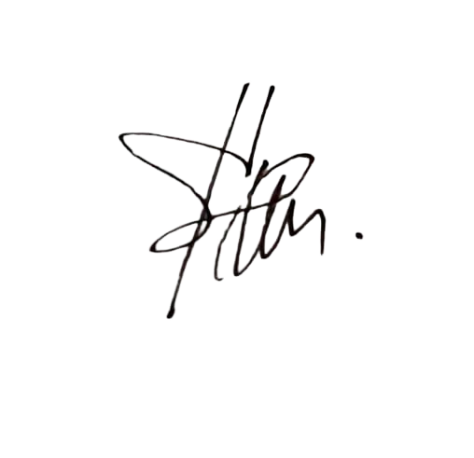  IT Business Analyst | IT Division Head | IT Developer – Developer | IT Developer – Coordinator / Leader
Signature | 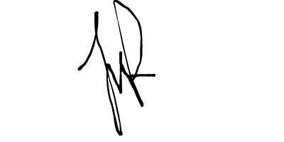 |  |  | 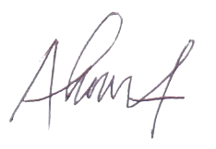
Printed Name | Januar Aransyah | Ateng Moch. Yasin Rachim | Andez | Ahmad Zulfahmi
Position | Head Of IT Business Analyst | Head of IT | IT Development | Head of IT Development
Date | 08 Desember 2021 |  | 08 Desember 2021

Document History

Version | Issue Date | Change Description | Initial | Reviewer / Logic Inspector | Approver | Approver | Approver
V 1.1

Contact for Enquiries

If you have any questions regarding this document, please contact:
Name : Januar Aransyah
Title : Business Analyst
Ext. : 1118
E-mail : januar.aransyah@takaful.com

Table of Content
1. UAT Environment 4
2. UAT Scenario 5
3. SCREEN SHOOT 8
4. OPEN ISSUES 12
5. UAT Person In Charge 22

1. UAT Environment
Testing Address : | Starsba.takaful.com
Description : | Insert Alamat Email Otomatis Pembatalan Piutang
Prepared By : |  | Reviewed By :
UAT From : | <Desember> <07>, <2021>
UAT To : | <Desember> <10>, <2021>
UAT Creator & Execute | Januar Aransyah
Testing User
Achmad Meidiana Sucipto | UAT-STARS
Scope : | Pengecekan alamat email kirim sesuai dengan email Agent

2. UAT Scenario

No | Scenarios | Expected Result | Actual Result | Defect / Remark | Pass / Fail
1 | Fitur INVOICE DATE | ketika INVOICE DATE diinsert muncul data pesertanya (cth INVOICE DATE 07/12/2021) | As expected |  | Pass
2 | Fitur CANCEL DATE | ketika CANCEL DATE diinsert muncul data pesertanya (cth INVOICE DATE 07/12/2021) | As expected |  | Pass
3 | Fitur SEND DATE | ketika CANCEL DATE diinsert muncul data pesertanya (cth INVOICE DATE 07/12/2021) | As expected |  | Pass
4 | Fitur button SEND all | Ketika peserta diceklis lebih dari satu lalu klik send terkirim semua email pembatalan sesuai email penerima yang muncul. (cth regno 20211207142556503, U20200923163526027002, 20200827093102397, 20211105133551417) | As expected |  | Pass
5 | BRANCH pada lampiran surat pembatalan | BRANCH muncul pada lampiran surat pembatalan (cth regno 20211207142556503) | As expected |  | Pass
6 | Auto insert email TO & CC | Email TO & CC muncul pada kolom yang tersedia di menu Send Email - Pembatalan Piutang (cth regno 0000372_16492, 20210218103850840, 20210312133724287-R1) | As expected |  | Pass
7 | Edit email TO & CC | Email TO & CC yang sudah muncul otomatis pada kolom yang tersedia di menu Send Email - Pembatalan Piutang dapat di edit, jika ada perubahan alamat email. (cth regno 0000372_16492, 20210218103850840, 20210312133724287-R1) | As expected |  | Pass

3. SCREEN SHOOT
- Fitur INVOICE DATE (cth INVOICE DATE 07/12/2021)
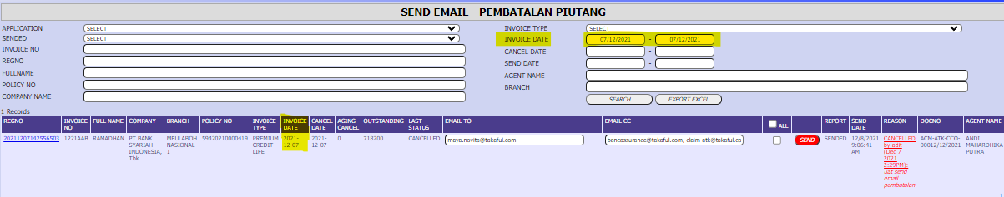

- Fitur CANCEL DATE (cth CANCEL DATE 07/12/2021)
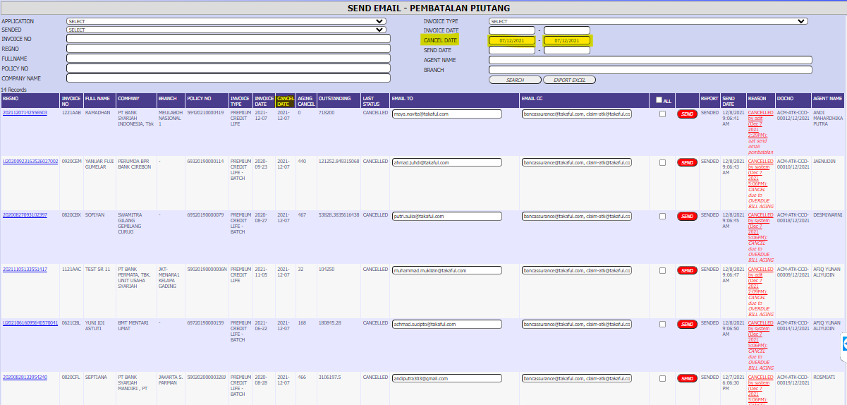

- Fitur SEND DATE (cth SEND DATE 07/12/2021)
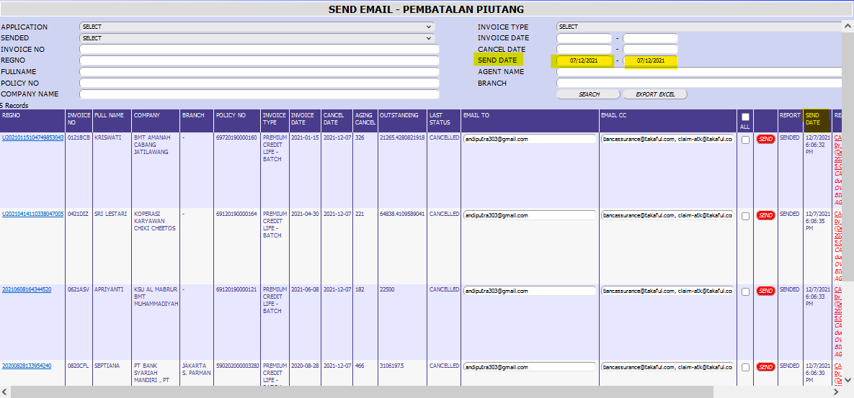

- Fitur button SEND all (cth regno 20211207142556503, U20200923163526027002, 20200827093102397, 20211105133551417)
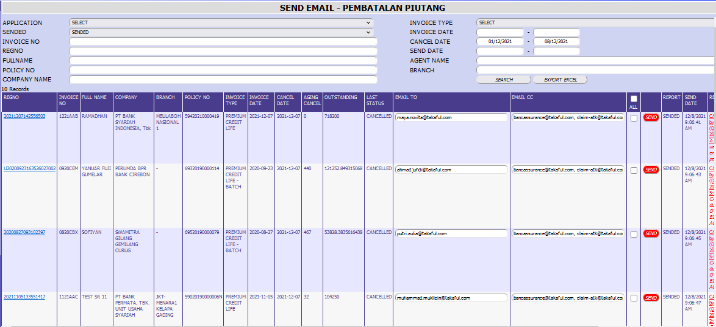

20211207142556503
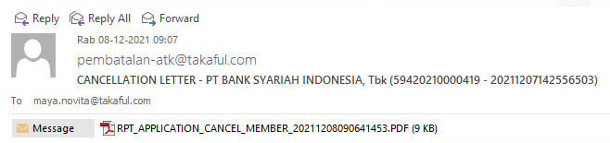
U20200923163526027002
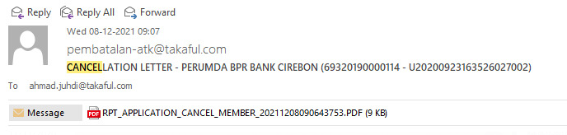
20200827093102397
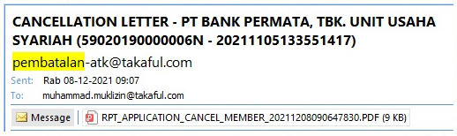
20211105133551417
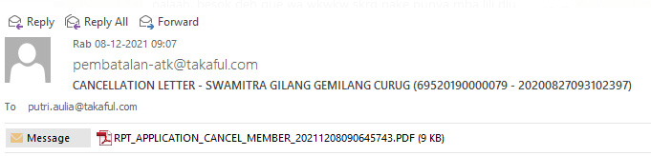

- BRANCH pada lampiran surat pembatalan (cth regno 20211207142556503)
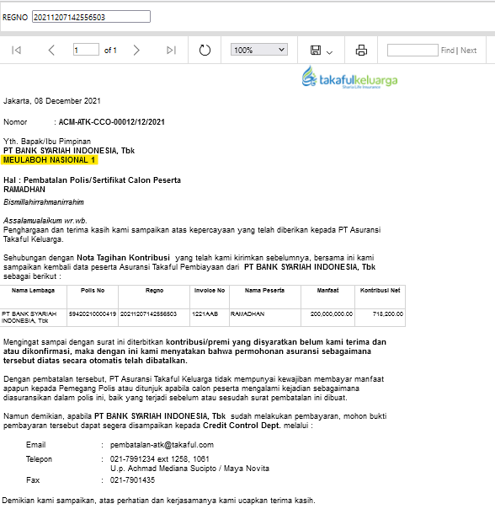

- Auto insert email TO & CC (cth regno 0000372_16492, 20210218103850840, 20210312133724287-R1)
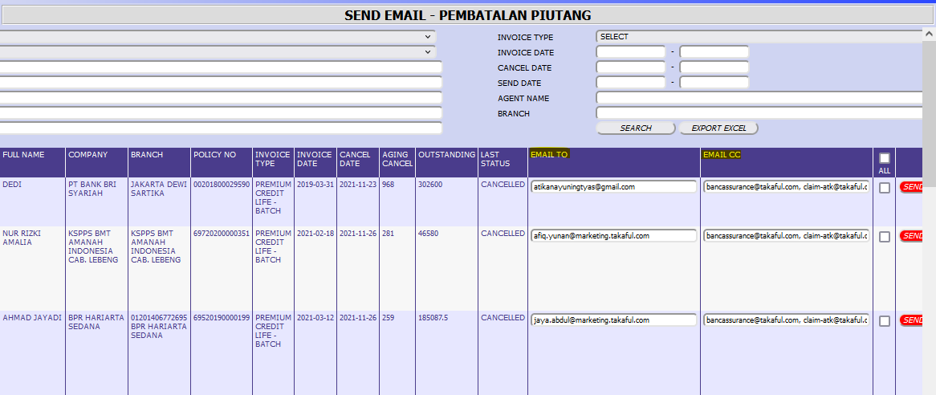

- Edit email TO & CC (cth regno 0000372_16492, 20210218103850840, 20210312133724287-R1)
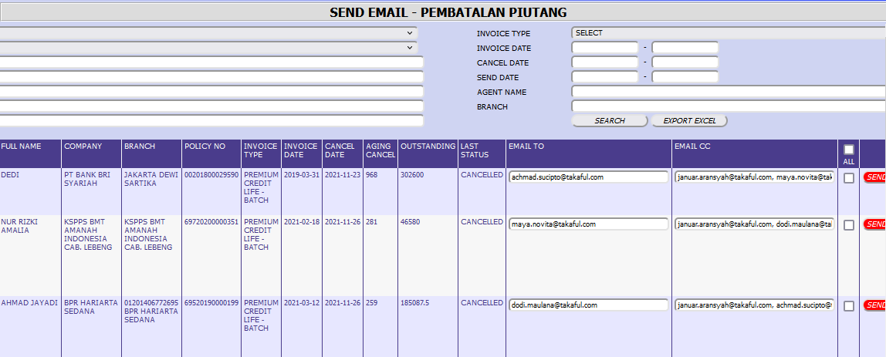

4. OPEN ISSUES
No | Name | Notes
5. UAT Person In Charge
No | Name | Level | Position
1 | Januar Aransyah | Manager | Business Analyst
2 | Achmad Meidiana Sucipto | Officer | Credit control
3

